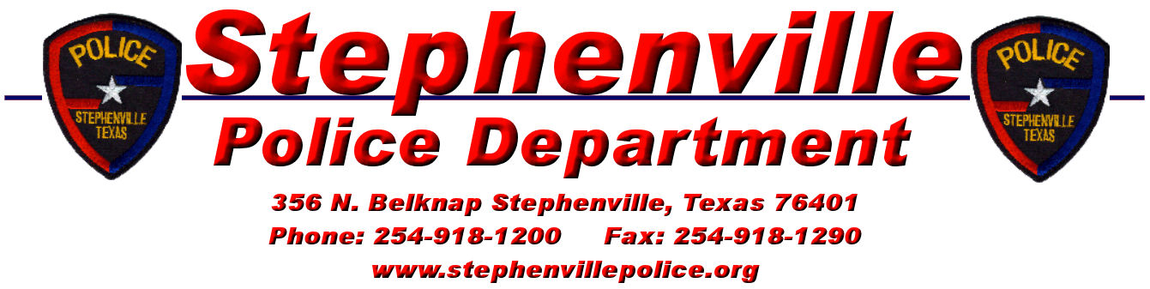
How Are You Today

Date: _____________________
Name: ________________________________________________________________
Address: ______________________________________________________________
Telephone Number: __________________ Time to be called: __________ to ________

Do you reside in the City of Stephenville? Yes No
Are you 62 or older? Yes No
Do you live alone? Yes No
Are you bedridden or convalescing? Yes No
List any known illnesses or injuries: _________________________________________
______________________________________________________________________
______________________________________________________________________

Location of house key:
_____Police Department
_____Other: ___________________________________________________________

Doctor: _________________________________________ Phone: _______________
Clergy: ______________________________________ Phone: ___________________

In the event of an emergency, who should be notified?
Name: ___________________________________ Phone:_____________________
Address: ______________________________________________________________

Do you have Dangerous pets? Yes No
Type and location of pets: ______________________________________________________________________
- Interruption of Service: The Stephenville Police Department assumes no liability for delays of services due to strikes, riots, flood, fires, acts of God, mechanical or electrical equipment failures, or any cause beyond the control of the PD, and will not be required to supply service while said interruption may continue.
- No Warrant or Representation: The Stephenville PD does not represent or warrant that the system may not be compromised or circumvented or that the system will prevent any personal injury, loss of life or property or disclaims any implied warranties, including the implied warranties of merchantability or fitness for a particular purpose, and the participant acknowledges that any affirmation of fact or promise made by the PD or its agents, servants or employees, shall not be deemed to create an express warranty.
- The Stephenville PD is not an Insurer/Limitation of Liability/Liquidated Damage Clause: It is understood and agreed that: The PD is not an insurer, that any insurance desired by the participant shall be obtained by the participant; that the PD makes no guarantee or warranty either express or implied of merchantability or fitness of the system that the services supplied will avert or prevent occurrences or the consequences therefrom which the system or service is designed to avert or detect. The participant acknowledges that it is impractical and extremely difficult to fix actual damages, if any, which proximately result from a failure by the PD to perform any of the obligations herein, including, but not limited to,
    - Failure of the System to Operate
    - Mechanical defects of the system
    - The PD’s active or passive negligence with resulting loss to the participant because of, among other things:
      - The uncertainty of the response time of the PD
      - The uncertain nature of occurrence which might cause injury or death to the participant or any other person which the system is designed to detect or avert
      - The limitation of the telephone lines or the telephone service connecting the system.
- Third party Indemnification: The participant agrees to and shall indemnify, defend and hold harmless, the PD, its employees, agents and related parties against and from all claims growing out of this agreement, or any alleged act or omission of the PD relating to its obligations undertaken or implied by this agreement, brought against (1) the participant or (2) the PD, its employees, agents and related parties by any person or persons. This indemnification and agreement to hold harmless includes, but is not limited to cost of defense including attorney’s fees, court costs and all related costs as well as any damages or other loss. This provision shall apply to all claims, regardless, express or implied warranty, contribution, indemnification or strict or product liability on the part of the PD, its employees or agents.
- Invalid Provisions: In the event that any of the terms or provisions of this agreement shall be invalid or inoperative, all of the other terms shall remain in full force and effect.

In witness whereof, the parties have signed this agreement as of the date listed:

___________________________________ _________________

Participant Date

___________________________________ _________________
Participant Date

